EAST FAIRFIELD UNITED METHODIST CHURCH
Pastor: Rev. Lisa Courtwright
Organist: Ruth Rowley Ministers: The Congregation
Pianist: Nancy Setinsek Choir Director: Randy Hart

Sunday, May 17, 2026
Seventh Sunday of Easter

*Please stand in body or spirit as you are able

Welcome! We invite you to take this time to prepare for worship. In these
moments, quiet your inner voice, become aware of being in community with
others, and open your heart and mind to the leading of the Holy Spirit.

GATHERING “I Found What I Wanted” - Carmichael
“Jesus, Keep Me Near the Cross” - Doane

CHRIST LIGHT ENTERS

MISSIONS AND MINISTRY UPDATEs Jeannie Arnoto, Liturgist

PREPARING OUR HEARTS AND MINDS FOR WORSHIP

WORDS OF PREPARATION AND CENTERING

PRELUDE “Just As I Am” - Woodworth

*CALL TO WORSHIP

Lift your voices and sing your praises to the Risen Christ.
We come before our Lord with joy and thanksgiving.

Our God is full of majesty and power.
We come before our Lord with praise and awe.

Our God is awesome, giving power and strength to the people.
We come today to proclaim the glory of our Lord.

*OPENING PRAYER
Holy God, meet us in this place and surround us with your presence. Open our minds to your word, our hearts to your love, and our spirits to your wisdom and truth. May our worship honor you as we seek to know you more fully; through Jesus Christ our Lord. Amen.

*OPENING HYMN “Lord, Be Glorified” TFWS # 2150
(see insert or screen)

READING FROM THE PSALMS Psalm 68:4-10, 32-35 (NIV) pg 465

CHILDREN’S MOMENT

CHOIR ANTHEM “Heaven’s Endless Refrain” - McPheeters

OFFERING OURSELVES & OUR GIFTS
INVITATION
OFFERTORY “Blessed Be the Name” Anon. Tune
*DOXOLOGY UMH #95
*DEDICATION OF GIFTS

SEEKING GOD’S WORD

OLD TESTAMENT READING Jeremiah 9:23-24 (NIV) pg 623

SHARING OF JOYS & CONCERNS
SILENT PRAYER
PASTORAL PRAYER
THE LORD’S PRAYER

*HYMN “Take Time to Be Holy” UMH #395

SERMON TEXT John 17:1-11 (NIV) pg 877

SERMON That They Know You Pastor Lisa

RESPONDING TO GOD’S WORD

*CLOSING HYMN “More Love to Thee, O Christ” UMH #453

SENDING FORTH WITH BLESSING
*BLESSING
LIGHT OF CHRIST GOES INTO THE WORLD

~ Go with joy to serve the Lord ~

As we conclude our service, please join us downstairs for a time to relax, continue conversations, and enjoy coffee and refreshments.

Sound: Bill Rowley
Computer: Vicki Freeman
Livestream: Keith Wilhelm
Next Sunday: David Vollnogle, Liturgist
Please keep in mind that the service is live-streamed and
recorded for public access. Please keep prayer requests
brief and do not use last names or identifying details.

PRAYER REQUESTS MAY 17, 2026
To submit a prayer request call Denise at 330-457-2465 or 330-727-9832

If you desire a home or hospital visit call Pastor Lisa (440-339-6463)

Prayer Blankets: call Joyce Ward (330-692-3346)

Gary - PET Scan May 12. Then doctors will determine next steps.
Emily (Kay) – medical issue.
Diane & Rocky – sold their house. Packing and moving furniture into
storage while they find a house in this area.
Susan (Missy’s friend) – Had foot surgery. Prayers for healing and comfort.
John (Brent & Becky’s friend) – severe 4-wheeler accident months ago.
Now in rehab. Cannot use his hands yet. Prayers for healing.

Georgia – Please continue prayers. Looking for a rehab facility.
Dick – recovering from back surgery April 23. Doing well. Still healing.
Bill C – Now at home. Waiting for numbers to improve before surgery.
Jim B – Continued prayers.
Linda W – prayers for healing.
Sue (Kermit’s wife) – at Briarfield in Boardman for rehab.

HOMEBOUND
Dolly K. Bill & Barb H. Anita M.
Tom & Marie Linda S. Walt D. (Parkside)
Dorothy F. Esther C. Zelda C. (Whispering Pines)

IN MINISTRY
Lisa Courtwright Edie Boles Jeff Pellin

Ch Ph: 330-457-2465 Pastor: 440-339-6463
Email: revlisa18@gmail.com Ch Email:efumc@comcast.net Website: www.eastfairfieldumc.com CCLI # 1994841 CVLI #504 011 134


East Fairfield
United Methodist Church

May 17, 2026
9:30 AM



Rev. Lisa Courtwright
440-339-6463
45675 State Route 558
New Waterford, OH 44445

“Working, playing, and praying together on our
faith journey, to share Jesus Christ with everyone.”

Sun | Mon | Tue | Wed | Thu | Fri | Sat
May 17  9:30 Worship  10:30 Coffee  10:45 Sunday  School  4:00 4H  (Hannah Farmer) | May 18  7:00  LEADERSHIP  BOARD | May 19  8:00 Men’s  Coffee at  Larrys pavilion | May 20 | May 21 | May 22  Pastors Day Off  Office closed | May 23  8:30-10:00  Caring for  God’s  Lambs
May 24 PENTECOST  9:30 Worship  10:30 Coffee  10:45 Sunday  School  12:30 Memorial  Service and  PICNIC at the  Pavilion | May 25 | May 26  8:00 Men’s  Coffee at  Larrys pavilion  Newsletter  Deadline | May 27 | May 28  9:00 Mailing Committee  7:00 Scripture & Suds at Sundog | May 29  Pastors Day Off  Office Closed | May 30
May 31  9:30 Worship  10:30 Coffee  10:45 Sunday  School  5:00 Potluck Fellowship at Emmanuel UM | June 1 | June 2  8:00 Men’s  Coffee at  Larrys pavilion | June 3 | June 4 | June 5  Pastors Day Off  Office Closed | June 6
June 7  (Communion)  9:30 Worship  10:30 Coffee  10:45 Sunday  School | June 8 | June 9  8:00 Men’s  Coffee at  Larrys pavilion  Ladies’Day | June 10  7:00 Scripture & Suds at  Brew Lounge @ Firestone Farms  Annual Conference June 10-13 | June 11 | June 12  Pastors Day Off  Office Closed | June 13

LAST WEEK’S ATTENDANCE (May 10)
In-Person: 69 Online: 34

Mission of the Month ~ Fund #64 - Farmer to Farmer


4C’s Item ~ Juice
(apple, grape, or fruit juice)
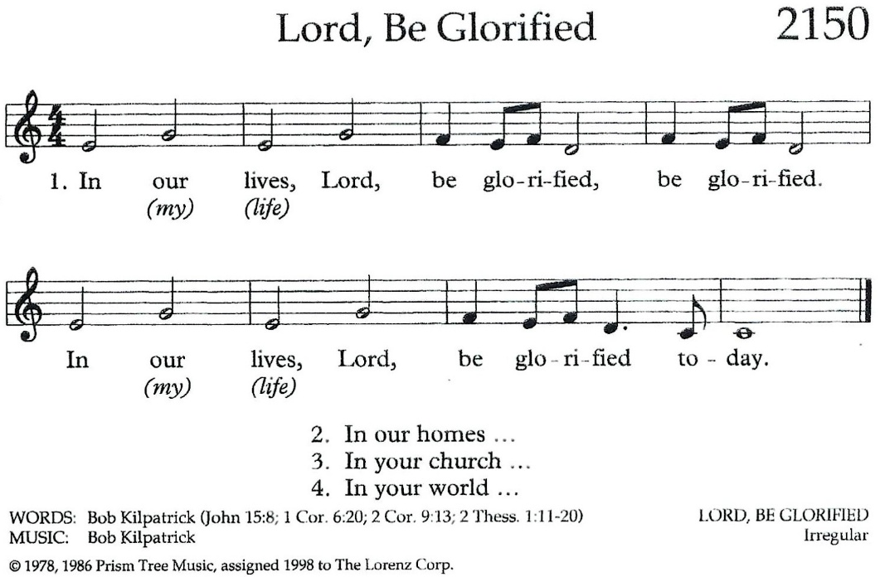

Update on Mission Giving for 2026
FUND | NAME OF FUND | NEED | RECEIVED | STILL NEED
2 | General Mission Fund | 5,099 | 2,871 | 2,228
33 | 4C’s | 125 | 175 | 0
32 | Cub Scouts | 150 | 405 | 0
37 | Way Station | 150 | 160 | 0
22 | Flat Rock | 175 | 265 | 0
64 | Farmer to Farmer – Liberia | 300 | 160 | 140
13 | UMCOR Sunday | Any  Donation | 75
21 | UMCOR – U.S. Disasters | Any  Donation | 5
14 | Blanket Sunday | Any  Donation | 65
15 | Peace With Justice | Any  Donation | 0
16 | World Communion | Any  Donation | 0
17 | Student Day | Any  Donation | 0
46 | Heroes & Halos | Any  Donation | 100
63 | InStep Program | Any  Donation | 20
38 | Operation Christmas Child Shoeboxes |  | 118 plus 30

Fund Balances as of end of March
Fund # 1 Ministry Operating -10,673
Fund # 2 Mission Fund 2,526
Fund # 3 Building Fund 61,545
Fund # 28 Elevator Fund 3,966

